Independent Components as Regions of Interest (Peak Coordinates and Spatial Maps)
              - Peak Coordinates of Components of Interest
Selected Components as Regions of Interest | X | Y | Z
Subcortical network (SC)
Caudate (1) | 6.5 | 10.5 | 5.5
Subthalamus/hypothalamus (2) | -2.5 | -13.5 | -1.5
Putamen (3) | -26.5 | 1.5 | -0.5
Caudate (4) | 21.5 | 10.5 | -3.5
Thalamus (5) | -12.5 | -18.5 | 11.5
Auditory network (AUD)
Superior temporal gyrus ([STG], 6) | 62.5 | -22.5 | 7.5
Middle temporal gyrus ([MTG], 7) | -42.5 | -6.5 | 10.5
Sensorimotor network (SM)
Postcentral gyrus ([PoCG], 8) | 56.5 | -4.5 | 28.5
Left postcentral gyrus ([L PoCG], 9) | -38.5 | -22.5 | 56.5
Paracentral lobule ([ParaCL], 10) | 0.5 | -22.5 | 65.5
Right postcentral gyrus ([R PoCG], 11) | 38.5 | -19.5 | 55.5
Superior parietal lobule ([SPL], 12) | -18.5 | -43.5 | 65.5
Paracentral lobule ([ParaCL], 13) | -18.5 | -9.5 | 56.5
Precentral gyrus ([PreCG], 14) | -42.5 | -7.5 | 46.5
Superior parietal lobule ([SPL], 15) | 20.5 | -63.5 | 58.5
Postcentral gyrus ([PoCG], 16) | -47.5 | -27.5 | 43.5
Visual network (VIS)
Calcarine gyrus ([CalcarineG], 17) | -12.5 | -66.5 | 8.5
Middle occipital gyrus ([MOG], 18) | -23.5 | -93.5 | -0.5
Middle temporal gyrus ([MTG], 19) | 48.5 | -60.5 | 10.5
Cuneus (20) | 15.5 | -91.5 | 22.5
Right middle occipital gyrus ([R MOG], 21) | 38.5 | -73.5 | 6.5
Fusiform gyrus (22) | 29.5 | -42.5 | -12.5
Inferior occipital gyrus ([IOG], 23) | -36.5 | -76.5 | -4.5
Lingual gyrus ([LingualG], 24) | -8.5 | -81.5 | -4.5
Middle temporal gyrus ([MTG], 25) | -44.5 | -57.5 | -7.5
Cognitive-control network (CC)
Inferior parietal lobule ([IPL], 26) | 45.5 | -61.5 | 43.5
Insula (27) | -30.5 | 22.5 | -3.5
Superior medial frontal gyrus ([SMFG], 28) | -0.5 | 50.5 | 29.5
Inferior frontal gyrus ([IFG], 29) | -48.5 | 34.5 | -0.5
Right inferior frontal gyrus ([R IFG], 30) | 53.5 | 22.5 | 13.5
Middle frontal gyrus ([MiFG], 31) | -41.5 | 19.5 | 26.5
Inferior parietal lobule ([IPL], 32) | -53.5 | -49.5 | 43.5
Right inferior parietal lobue ([R IPL], 33) | 44.5 | -34.5 | 46.5
Supplementary motor area ([SMA], 34) | -6.5 | 13.5 | 64.5
Superior frontal gyrus ([SFG], 35) | -24.5 | 26.5 | 49.5
Middle frontal gyrus ([MiFG], 36) | 30.5 | 41.5 | 28.5
Hippocampus ([HiPP], 37) | 23.5 | -9.5 | -16.5
Left inferior parietal lobule ([L IPL], 38) | -47.5 | 5.5 | 22.5
Middle cingulate cortex ([MCC], 39) | -15.5 | 20.5 | 37.5
Inferior frontal gyrus ([IFG], 40) | 39.5 | 44.5 | -0.5
Middle frontal gyrus ([MiFG], 41) | -26.5 | 47.5 | 5.5
Hippocampus ([HiPP], 42) | -24.5 | -36.5 | 1.5
Default-mode network (DM)
Precuneus (43) | -8.5 | -66.5 | 35.5
Precuneus (44) | -12.5 | -54.5 | 14.5
Anterior cingulate cortex ([ACC], 45) | -2.5 | 35.5 | 2.5
Posterior cingulate cortex ([PCC], 46) | -5.5 | -28.5 | 26.5
Anterior cingulate cortex ([ACC], 47) | -9.5 | 46.5 | -10.5
Precuneus (48) | -0.5 | -48.5 | 49.5
Posterior cingulate cortex ([PCC], 49) | -2.5 | 54.5 | 31.5
Cerebellar network (CB)
Cerebellum ([CB], 50) | -30.5 | -54.5 | -42.5
Cerebellum ([CB], 51) | -32.5 | -79.5 | -37.5
Cerebellum ([CB], 52) | 20.5 | -48.5 | -40.5
Cerebellum ([CB], 53) | 30.5 | -63.5 | -40.5
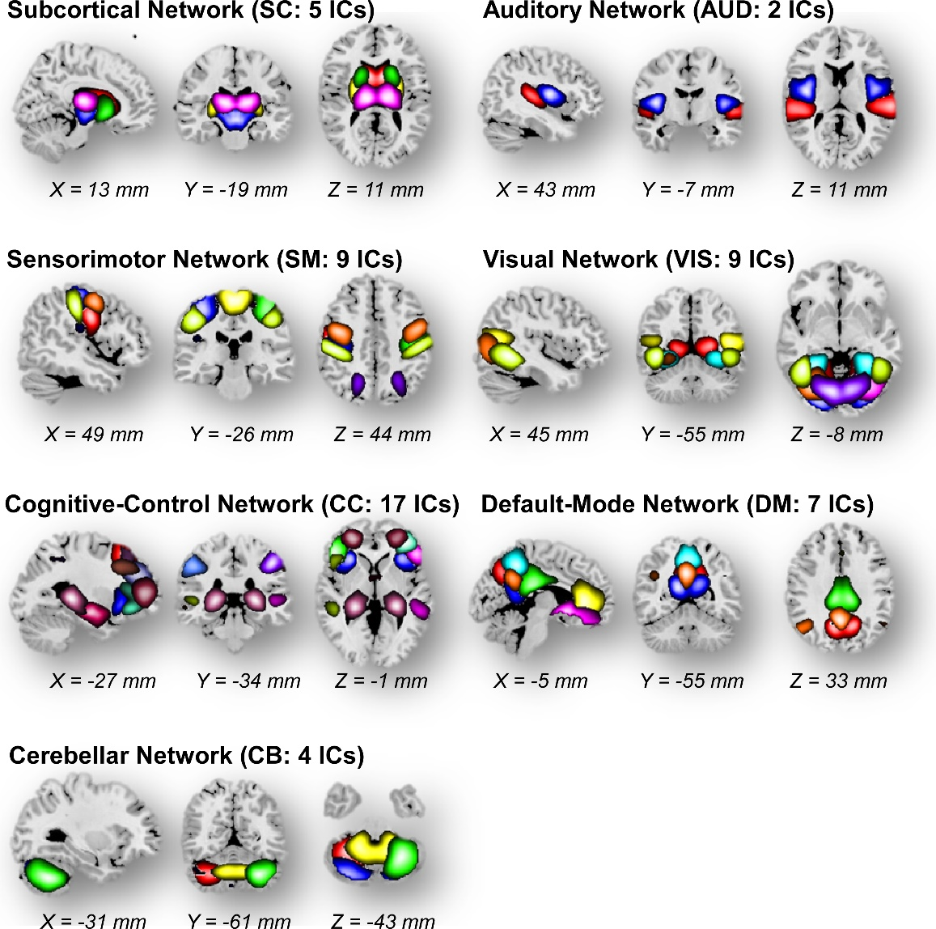
            - Brain template components extracted by group ICA. Spatial maps of the 53 independent components are arranged into 7 functional networks according to the anatomic and functional prior knowledge.

